# Java Final Culminating Proposal

By: Jason You (Ms.Costin)

**Type of Game:** Question and Answer Game

**Description of Game:** This game is one where the user is given a set of questions that they have to answer based on knowledge. The questions for each set are randomized and the users are given points depending on the type of word that he/she enters. (E.g. If the question asks for a type of bird and the user enters a bird name that is unknown, then the user will be given points.) However, the questions for each of the levels will be of varying difficulty. The questions in level 1 will be simple, the questions in level 2 will be of intermediate level and the questions in level 3 will be hard. Also, the user will be asked to choose between three categories: technology, animals and general knowledge.

There are three levels and within these three levels, each level becoming increasingly difficult. If the user would like to quit the program, he/she would enter the word “quit”. When the user first enters the program, he/she will be given the choice of entering numbers 1-5: 1 is for level 1, 2 is for level 2, 3 is for level 3, 4 is for the help, and 5 is to exit the program.

The program will be error trapped so that when the user doesn’t input a proper value, a Frame window will pop up prompting the user to re-enter the value.

**Programming Concepts in the Game:**

* 1D/2D Arrays
* Object Oriented Programming
* Java GUI
* Inheritance, Polymorphism
* Animation
* File IO (For the high scores and the various answers)
* Import pictures/sounds

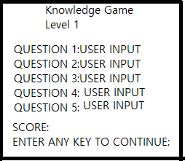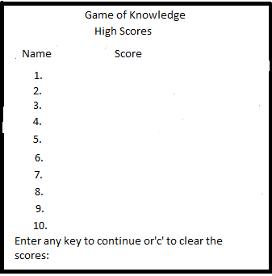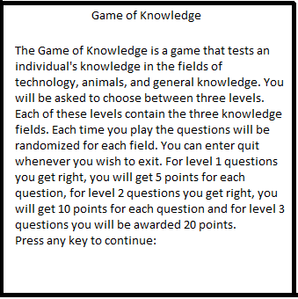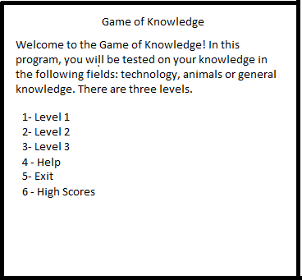

Example of one level

High Scores

Help

Main Menu